**Ralph J. Bunche Middle School**

**Date: August 15, 2023**

**Time: 6:00pm**

**Recording:** [https://www.youtube.com/live/oHSyXEapc1M?feature=share](https://nam11.safelinks.protection.outlook.com/?url=https%3A%2F%2Fwww.youtube.com%2Flive%2FoHSyXEapc1M%3Ffeature%3Dshare&data=05%7C01%7CShelia.Reed%40Atlanta.k12.ga.us%7Caf1f4b3c83624428796608db9e9040e1%7C0d95ef40a0dd431890985e10f876f635%7C0%7C0%7C638278114616162050%7CUnknown%7CTWFpbGZsb3d8eyJWIjoiMC4wLjAwMDAiLCJQIjoiV2luMzIiLCJBTiI6Ik1haWwiLCJXVCI6Mn0%3D%7C3000%7C%7C%7C&sdata=FUEE2U%2FvTXRNz7ctoz5PlWP%2Fb4NpbKjZK8Crp8c2gjA%3D&reserved=0)

1. **Call to order:** 6:05pm
2. **Roll Call**

|  |  |  |
| --- | --- | --- |
| **Role** | **Name** *(or Vacant)* | **Present or Absent** |
| **Principal** | **Kimberly Whitfield** | **Present** |
| **Parent/Guardian** | **Electra Evans** | **present** |
| **Parent/Guardian** | **Alexandria Rackston** | **absent** |
| **Parent/Guardian** | **Jasmine Robinson** | **absent** |
| **Instructional Staff** | **Akouvi Nakou** | **Present** |
| **Instructional Staff** | **Dominique Hood** | **Present** |
| **Instructional Staff** | **vacant** |  |
| **Community Member** | **Kevin Harris** | **present** |
| **Community Member** | **vacant** |  |
| **Swing Seat** | **vacant** |  |
| *Visitor* | **Sabrina Royal** | **present** |
| *Visitor* | **Diane Easley** | **present** |
|  |  |  |

**Quorum Established:** yes

1. **Action Items** *Fill Vacant positions; Election of Officers/Representatives; Review & Approve Public Comment Protocol; GO Team Meeting Calendar; GO Team Meeting Norms*
   1. **Approval of Agenda:** Motion made by: Principal Whitfield; Seconded by: Nakou

Members Approving: 4 of 4 (Nakou/Hood/Harris/Evans)

Members Opposing: 0

Members Abstaining: 0

**Motion** Passes

* 1. **Fill Vacant Positions** *(copy and complete table for each vacant position and indicate the individual who will fill the seat)*

|  |  |
| --- | --- |
| **Vacant Position:** | ***Parent, Staff, or Community*** |
| **Nominee’s Name:** | Gordon |
| GO Team Members  **In favor** | Nakou/Hood/Harris/Evans |
| GO Team Members **Opposed** | none |
| GO Team Members **Abstaining** | none |

* 1. **Fill Open Community Member Seat:**

|  |  |
| --- | --- |
| **Open Position:** | **Community Member** |
| **Nominee’s Name:** | Sabrina Royal |
| GO Team Members  **In favor** | Hood/Evans/Harris/Nakou |
| GO Team Members **Opposed** | None |
| GO Team Members **Abstaining** | None |
|  |  |

* 1. **Fill Open Swing Seat**

|  |  |  |
| --- | --- | --- |
| **Nominee’s Name:** | **Nominated by** | GO Team Members  **In favor** |
| **Diane Easley** | Principal Whitfield | Nakou/Hood/Harris/Evans |
|  |  |  |
|  |  |  |

GO Team Members who **ABSTAINED** from voting: None

**SWING SEAT RESULT: Diane Easley**

* 1. **Election of Officers and Representatives** 
     1. **Chair: Result:** Avron Gordon

|  |  |
| --- | --- |
| **Officer Position:** | **Chair** |
| **Nominee Name** | GO Team Members **In favor** of Nominee |
| **Avron Gordon** | Hood/Evans/Royal/Harris/Nakou |
|  |  |
|  |  |

GO Team Members who **ABSTAINED** from voting: none

* + 1. **Vice Chair: Result:** Dominique Hood

|  |  |
| --- | --- |
| **Officer Position:** | **Vice Chair** |
| **Nominee Name** | GO Team Members **In favor** of Nominee |
| **Dominique Hood** | Royal/Evans/Harris/Nakou/Gordon |
|  |  |
|  |  |

GO Team Members who **ABSTAINED** from voting: none

* + 1. **Secretary: Result:** Sabrina Royal

|  |  |
| --- | --- |
| **Officer Position:** | **Secretary** |

|  |  |
| --- | --- |
| **Nominee Name** | GO Team Members **In favor** of Nominee |
| **Sabrina Royal** | Harris/Hood/Evans/Nakou/Gordon |
|  |  |
|  |  |

GO Team Members who **ABSTAINED** from voting: none

* + 1. **Cluster Representative: Result:** Akouvi Nakou

|  |  |
| --- | --- |
| **Officer Position:** | **Cluster-Representative** |
| **Nominee Name** | GO Team Members **In favor** of Nominee |
| **Akouvi Nakou** | Hood/Harris/Evans/Royal/Gordon |
|  |  |
|  |  |

GO Team Members who **ABSTAINED** from voting: none

* 1. **Review and Approve Public Comment Protocol**

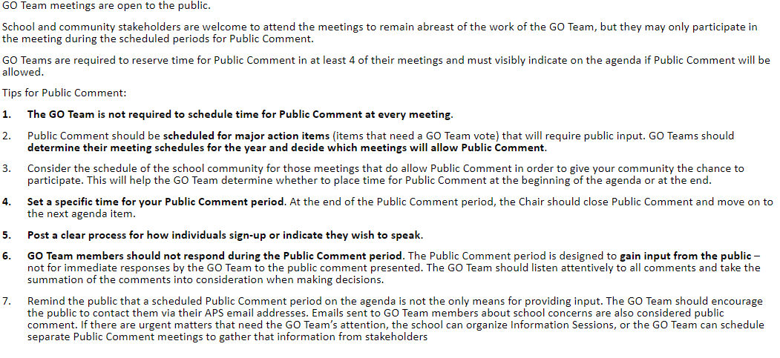

Motion to adopt made by: Dr. Kevin Harris; Seconded by: Royal

Members Approving: 5

Members Opposing: 0

Members Abstaining0

**Motion**Passes

* 1. **Set GO Team Meeting Calendar** *(GO Teams are required to have a minimum of 6 business meetings, with at least 4 allowing for Public Comment)*

|  |  |  |  |  |
| --- | --- | --- | --- | --- |
|  | **Date** | **Time** | **Virtual or Hybrid** | **Time for Public Comment? (Yes/No)** |
| **1** | **9/19/23** | **6:00** | **Hybrid** | **yes** |
| **2** | **10/17/23** | **6:00** | **Hybrid** | **no** |
| **3** | **11/28/23** | **6:00p** | **Hybrid** | **yes** |
| **4** | **12/19/23** | **6:00p** | **Hybrid** | **no** |
| **5** | **1/16/23** | **6:00p** | **Hybrid** | **no** |
| **6** | **2/27/23** | **6:00p** | **Hybrid** | **yes** |
| **7** | **3/19/23** | **6:00p** | **Hybrid** | **no** |
| **8** | **4/16/23** | **6:00p** | **Hybrid** | **yes** |

* 1. **Review, Confirm/Update, and Adopt GO Team Meeting Norms**

Motion to adopt made by: Royal; Seconded by: Harris

Members Approving: Hood/Royal/Evan/Harris/Nakou/Gordon

Members Opposing: 0

Members Abstaining 0

**Motion** Passes

1. **Information Items** 
   1. **Principal’s Update** Fully staffed. 10-Day Count. Accelerated Math. Biology. Earth Science. Advance Math/Algebra 1 (High School Credits)/B.O.S.S. theme
2. **Announcements** GOTeam Summit (9/23/23)/Member Training & Orientation (on APS website)
3. **Adjournment**

Motion made by: Dr. Harris; Seconded by: everyone

Members Approving: 5

Members Opposing: 0

Members Abstaining: 0

**Motion** Passes

**ADJOURNED AT** 7:01pm

-----------------------------------------------------------------------------------------------------------------------------

**Minutes Taken By:** Shelia Reed

**Position:** School Secretary

**Date Approved:** [Insert Date When Approved